Title (14 p, Arial)
Author name¹,
¹Department of Physics, University of ***, Republic of Korea
² Italic, 9 p, Times New Roman
¹aaa@abc.ac.kr
Abstract:
The abstract should be 10p Times New Roman.

- Some details
2.1 Title
The title and subtitles for each section should be 10p Arial. The subtitle should be in Italic form [1].
2.2 Figures and tables
The figures should be of high resolution.
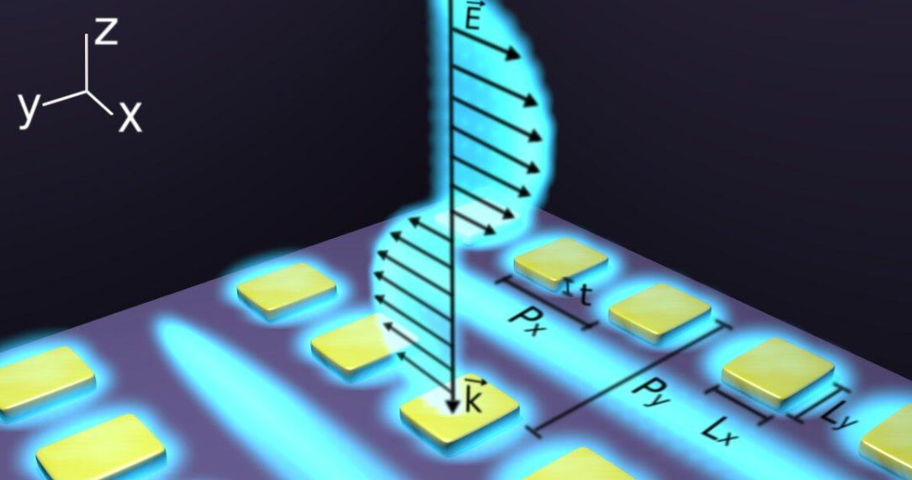
Fig. 1. Use 8p Times New Roman.
Tables should use horizontal lines to delimit the top and bottom of the table and column headings. Make the tables simple for the readers to read [1-3].
Table 1. Bold 8p Times New Roman for table titles
Properties | A | B |  | C | D
Design 1 | 1 | 3 |  | 5 | 7
Design 2 | 2 | 4 |  | 6 | 8
References
- Authors, “Title of paper,” Journal (year).

